**REPL and Module Assignment**

**Example1 : Iterating Over User-Entered Number**

* **Read**: rl.question() waits for user input.
* **Eval**: split(',') and map(Number) convert the input into an array of numbers.
* **Print**: A for...of loop prints each number.
* **Loop**: Only one prompt here, so no loop back – but REPL principles still apply through read → eval → print.
* This program prompts the user to **enter numbers separated by commas** (like 10,20,30).
* It splits the string input into an **array of numbers**.
* Then it uses a **for...of loop** to iterate through the array and print each number

const readline = require('readline');

const rl = readline.createInterface({

  input: process.stdin,

  output: process.stdout

});

rl.question("Enter comma-separated numbers (e.g. 1,2,3): ", function(answer) {

  const numArray = answer.split(',').map(Number);

  console.log("You entered:");

  for (let num of numArray) {

    console.log(num);

  }

  rl.close();

});

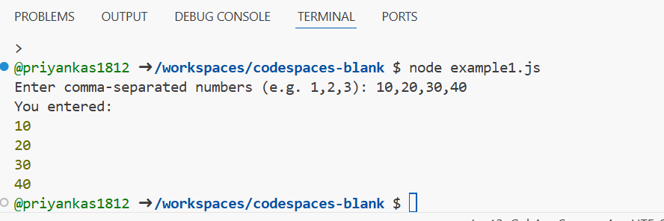

**Example 2 : Collecting User Names**

* **Read**: First question reads number of names; subsequent questions collect each name.
* **Eval**: Input is parsed using parseInt() and pushed to array.
* **Print**: Final loop prints all collected names.
* **Loop**: askName() recursively calls itself, acting like a custom REPL loop until all inputs are gathered.
* This program asks the user **how many names they want to input**.
* It then repeatedly prompts for that many names and stores them in an **array**.
* Once all names are entered, it prints each name using a **for loop**.

const readline = require('readline');

const rl = readline.createInterface({

  input: process.stdin,

  output: process.stdout

});

let names = [];

let count = 0;

rl.question("How many names do you want to enter? ", function(n) {

  n = parseInt(n);

  function askName() {

    if (count < n) {

      rl.question(`Enter name ${count + 1}: `, function(name) {

        names.push(name);

        count++;

        askName();

      });

    } else {

      console.log("\nList of names:");

      for (let i = 0; i < names.length; i++) {

        console.log(`Name ${i + 1}: ${names[i]}`);

}

  rl.close();

    }

  }askName();

});

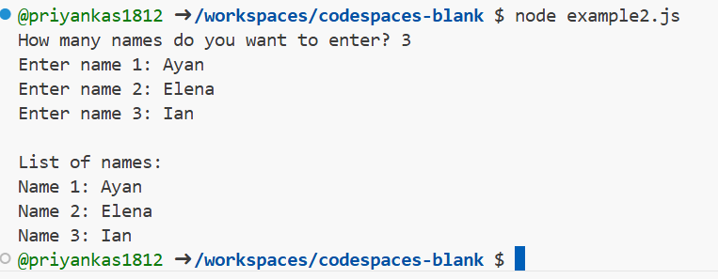

**Example 3 : Sum of Array Elements**

* **Read**: User input of numbers is accepted as a string.
* **Eval**: The input is split and summed using a for loop.
* **Print**: Displays the total sum.
* **Loop**: One-time read-eval-print cycle – REPL logic embedded in program flow.
* The user is asked to enter **space-separated numbers** (e.g. 5 10 15).
* The program creates a number array and calculates the **sum of all elements**.
* Uses a classic **for loop** to compute the sum.

const readline = require('readline');

const rl = readline.createInterface({

  input: process.stdin,

  output: process.stdout

});

rl.question("Enter space-separated numbers: ", function(data) {

  const arr = data.split(" ").map(Number);

  let sum = 0;

  for (let i = 0; i < arr.length; i++) {

    sum += arr[i];

  }

  console.log("Sum of array elements:", sum);

  rl.close();

});

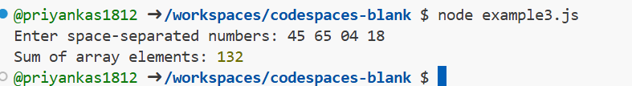

**Example 4 : Finding Even Numbers from User Input**

* **Read**: Accept space-separated numbers.
* **Eval**: Convert input to array and apply condition (num % 2 === 0).
* **Print**: Display even numbers only.
* **Loop**: Loop over array using for...of – simulates print cycle for each element.
* Asks the user to enter **space-separated integers** (e.g. 1 2 3 4 5 6).
* The program filters and prints only the **even numbers**.
* Uses a **for...of loop** and **conditional logic** (num % 2 === 0) to check for evennes

const readline = require('readline');

const rl = readline.createInterface({

  input: process.stdin,

  output: process.stdout

});

rl.question("Enter integers separated by spaces: ", function(input) {

  const nums = input.split(" ").map(Number);

  console.log("Even numbers:");

  for (let num of nums) {

    if (num % 2 === 0) {

      console.log(num);

    }

  }

  rl.close();

});

